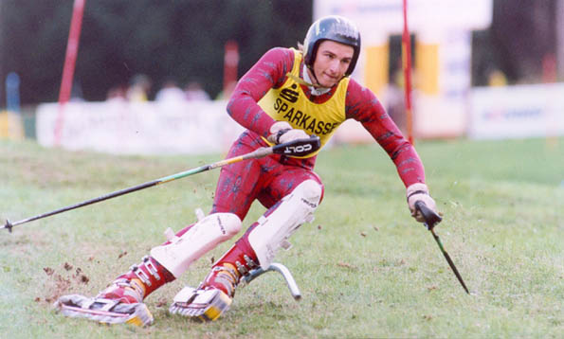

http://www.grasski.de/deutsch/d_Fram.htm
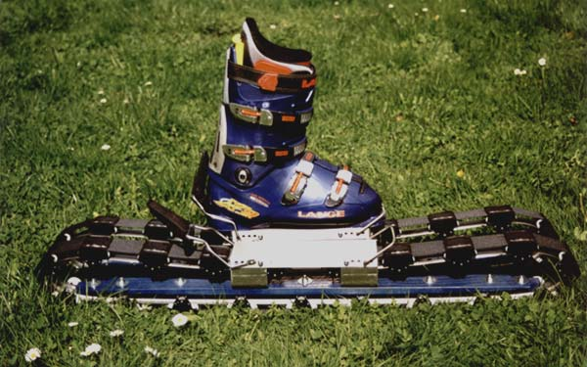

http://www.fis-ski.com/neuigkeitenundinformationen/diefisdisziplinen-beschreibung/grassski.html
Grass Skiing
Grass skiing makes use of many ski courses during the months when there is no snow. Competitors use skis that are based on a roller system and compete in Slalom, Giant Slalom and Super G events.

